# User Manual for EDF Viewer

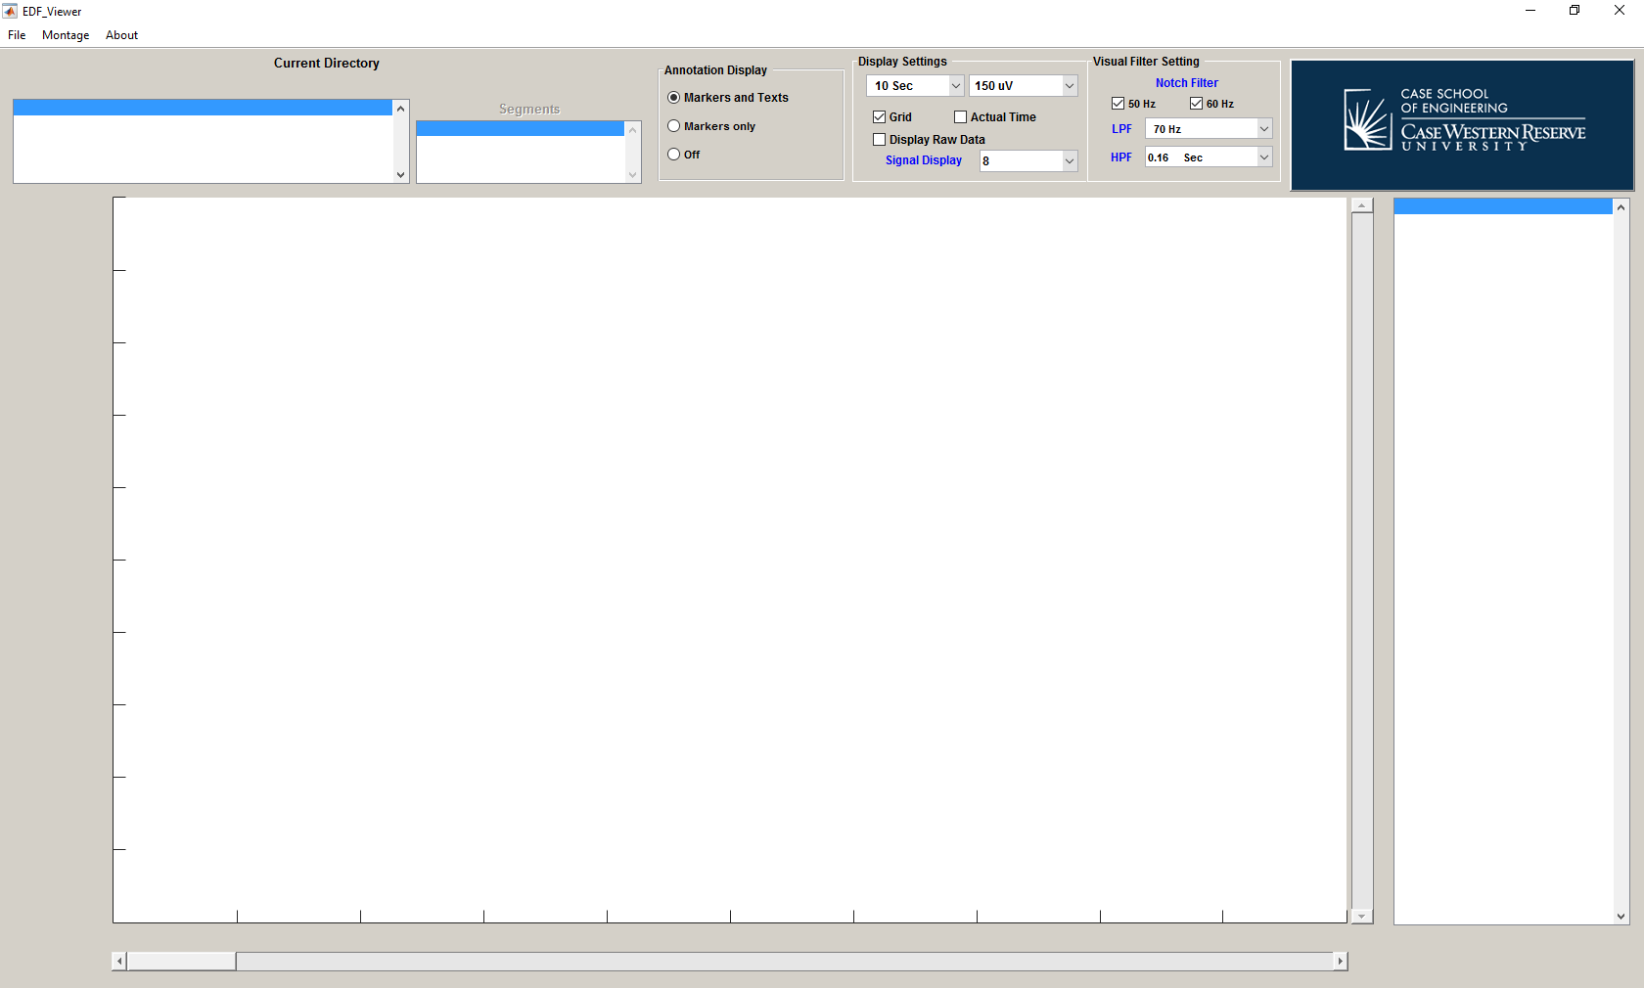

EDF Viewer is designed to visualize EDF data for CSR (Center for SUDEP Research) project. The annotation file associated with EDF file must be in text file with the same name as EDF file. Each column has the following format “HH:MM:SS.FFF [Text]”, e.g., “00:29:35.945 Pre Baseline”. The time specified in an annotation file is referenced with the beginning of EDF file and the delimiter between time and text is Tab. EDF Viewer can also open EDF+D and EDF+C files although it is not recommended due to limited testing procedure during the development.

# Getting Start

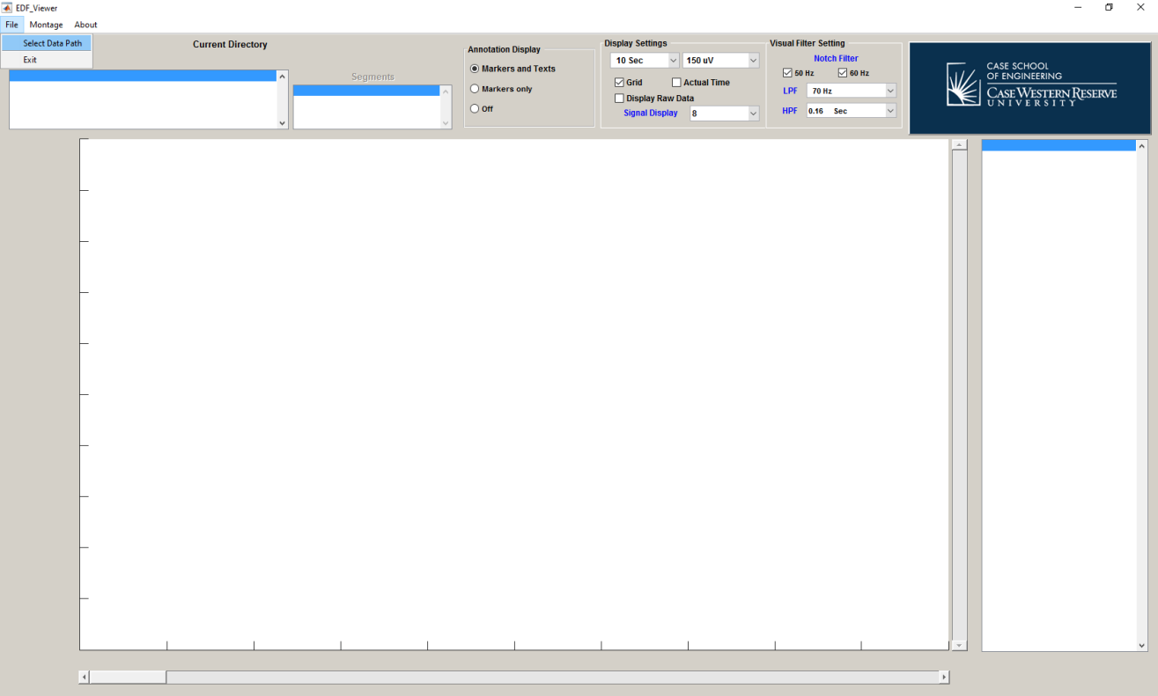

First open the “File” menu and click on “Select Data Path” to open the window to select the directory containing EDF files.

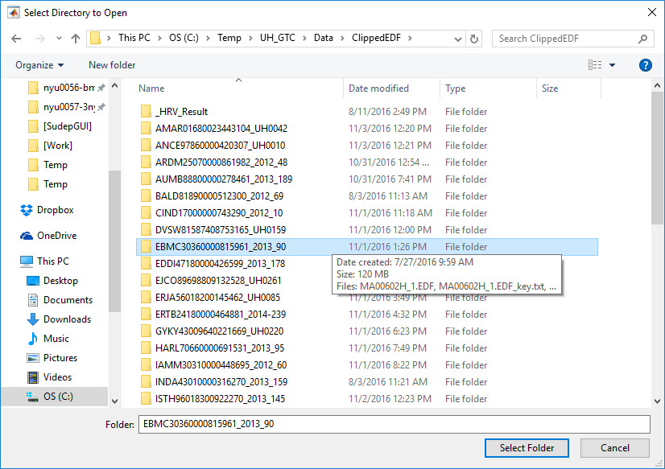

Then browse through the directory to locate the folder that contain EDF files and click “Select Folder” button. The list of EDF files will show up on the main windows. 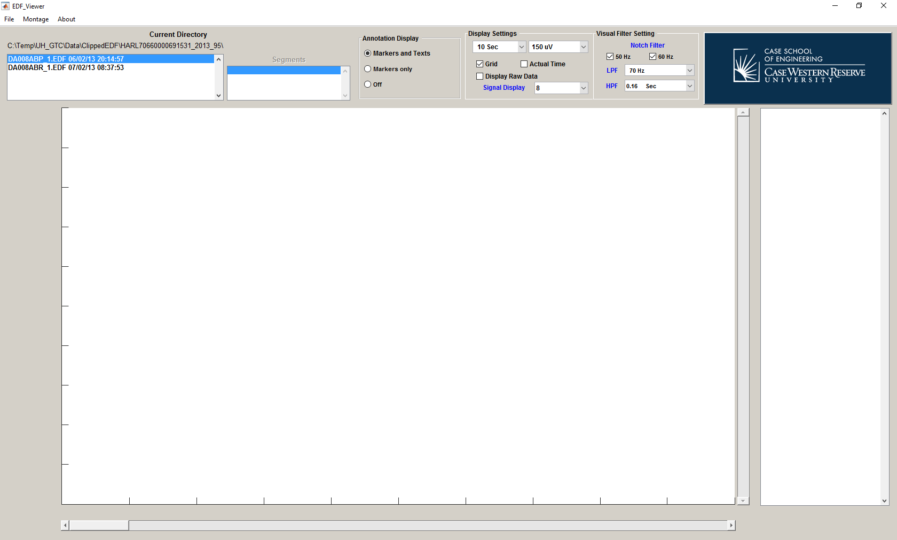

The click on the EDF file in the list to read the data. 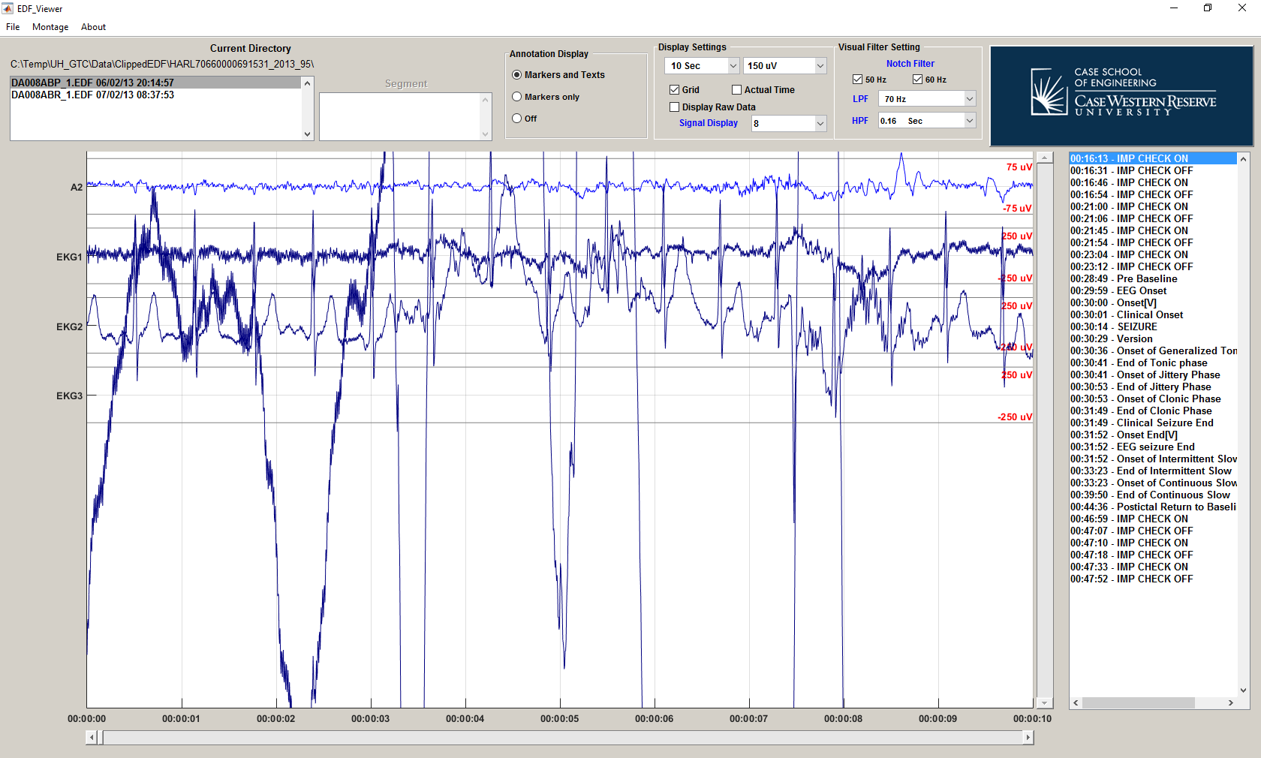

The names of display signals are on the left hand side while the physical units and scales are on the right hand side of display area. The clinical annotations from the text file is in the list box on the left side of main windows.



**Clinical Annotations**

**Range and units**

**Signals**

# Changing Signal on the Display (Change Montage)

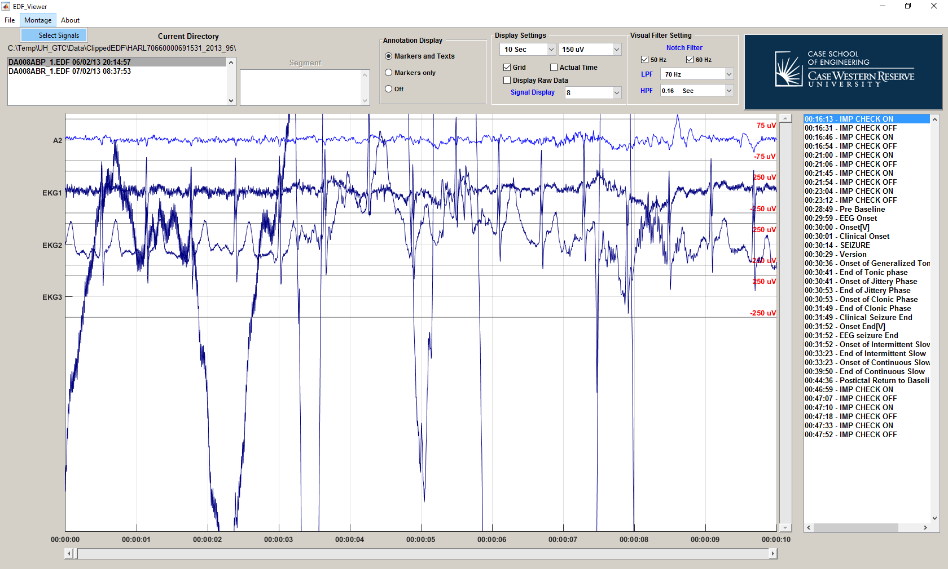

First click on the “Montage” menu and click on “Select Signals” to open the window to select signals to display on the main screen.

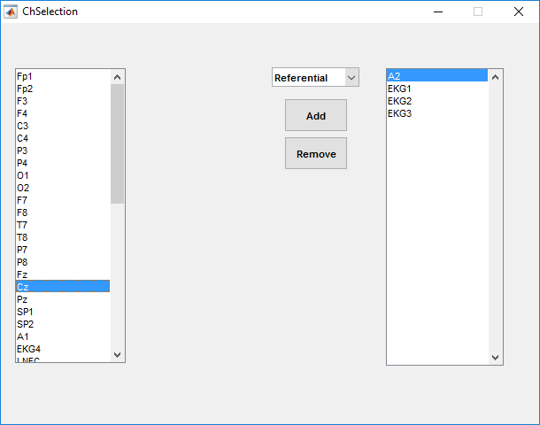 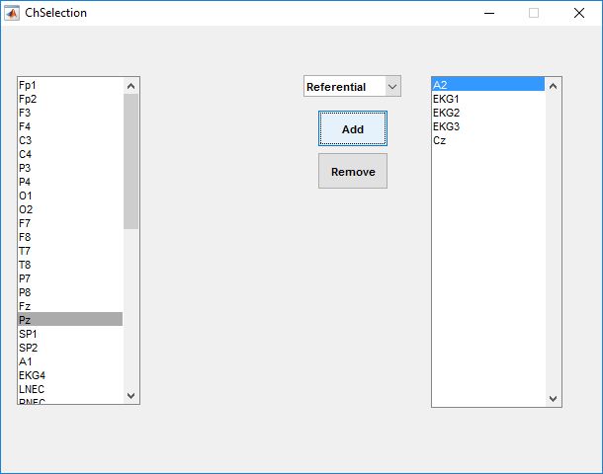

To add the signal to the display select the signal from the list in the left hand side an then click “Add” button. The selected signal will appear on the list in the right hand side which is the list of signal to be displayed on the main windows.

To add bi-polar signal, select “Bipolar” from the popupmenu located at the top-center of the channel selection window. Additional list will show up next to the list of signal in EDF file. To add referential signal, select “Referential” from the same popupmenu.

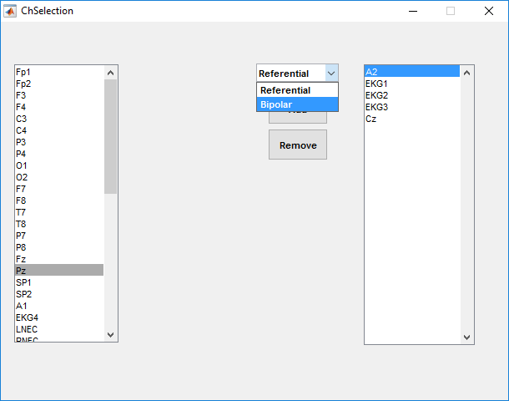 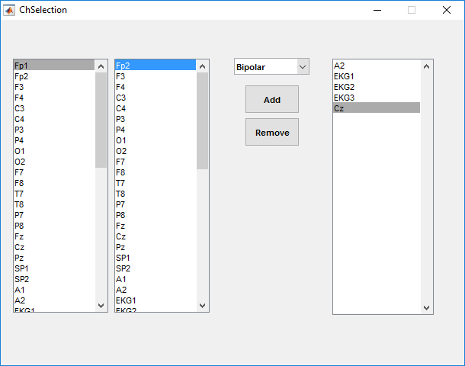

After that select the first signal from the first list box and then select the second signal from the second list box on the left hand side of the channel selection window. Then click “Add” button to include bipolar signals to the display.

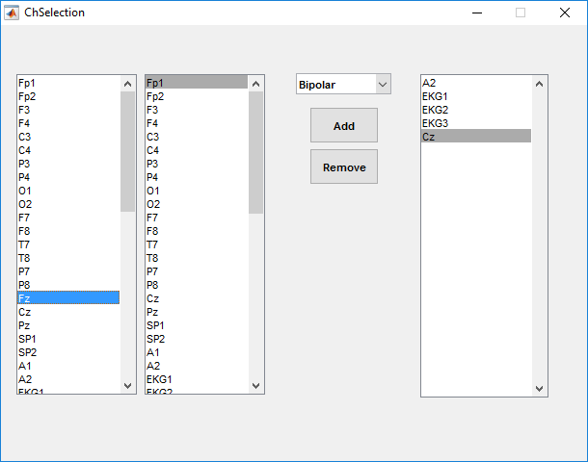 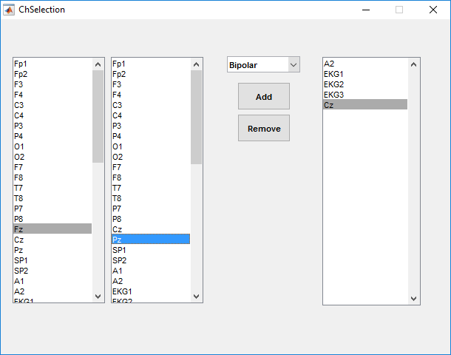

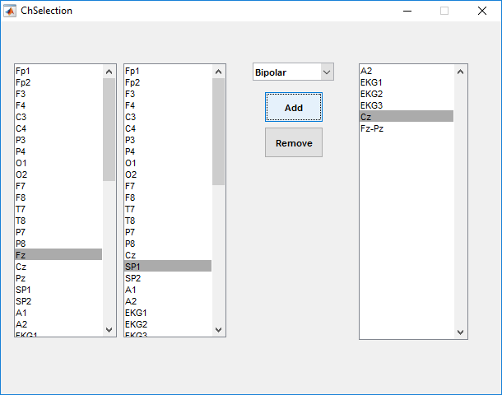

To remove the signal from the display select the signal from the list in the right hand side an then click “Remove” button. The selected signal will be removed from the display list.

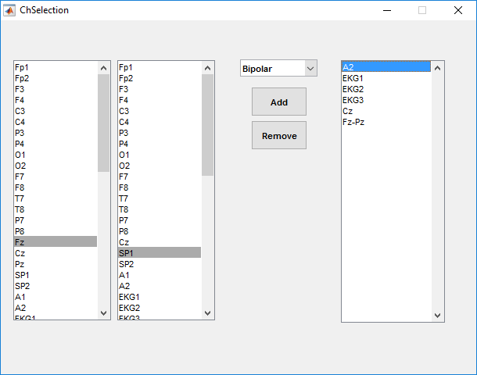 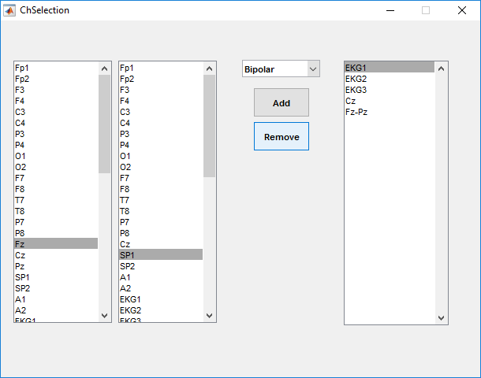

After finish adjusting the signals to be displayed, close the channel selecting window using “X” button on the top left.



The signal on the main windows will be changed according to the list on the right hand side of channel selection window.

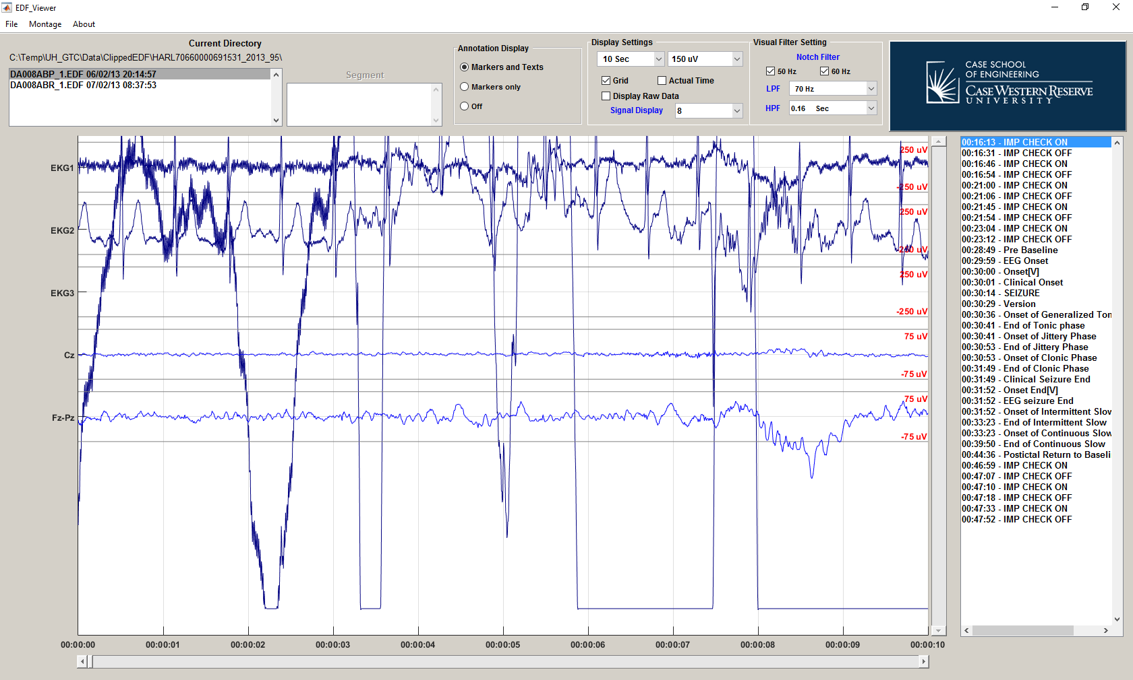

# Adjust basic display setting

User can turn on/off the marker for clinical annotations using the Annotation Display.

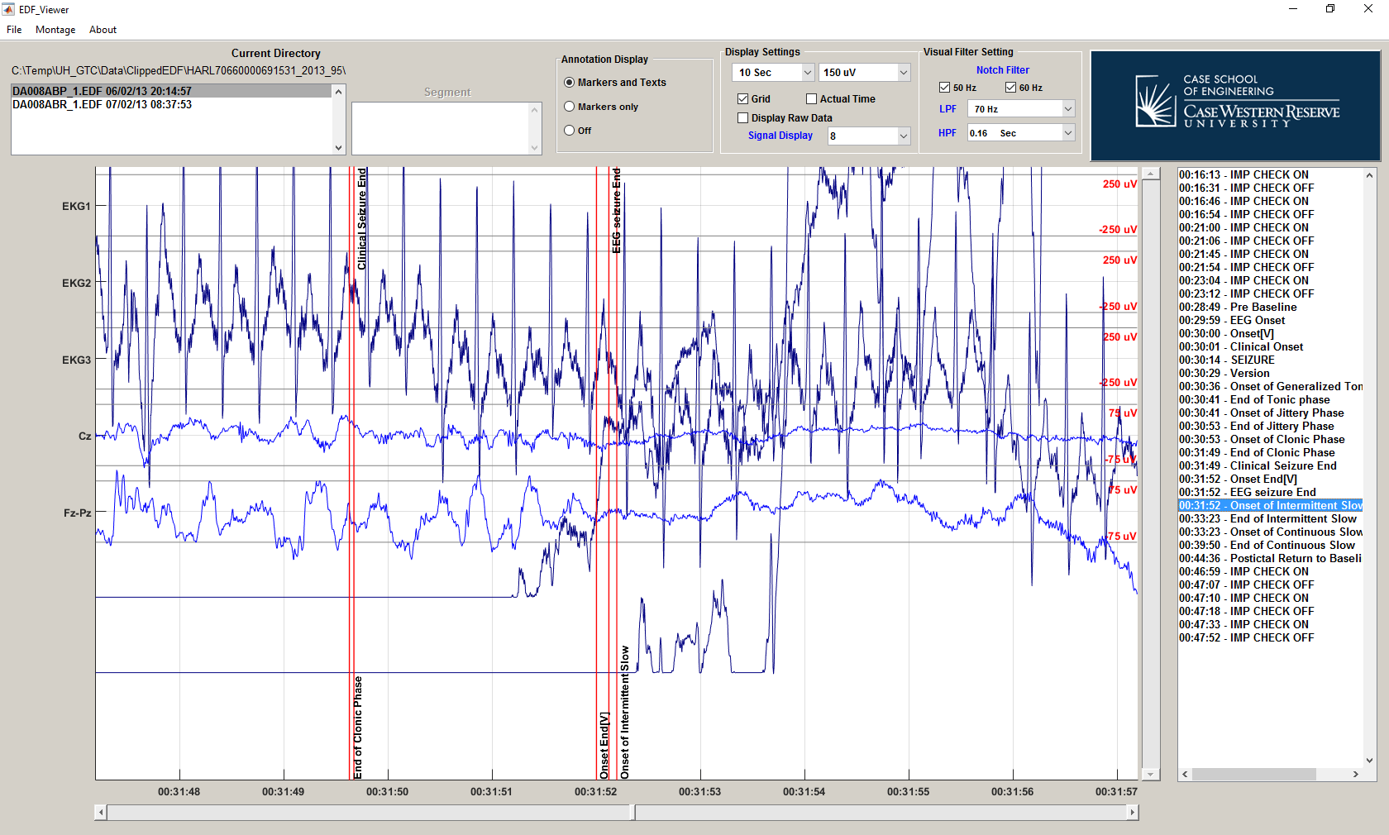

The first option, “Markers and Text”, will show the red line on the display screen along with associated text for clinical events. 

The second option, “Markers and Text”, will show the red line on the display screen without associated text for clinical events.

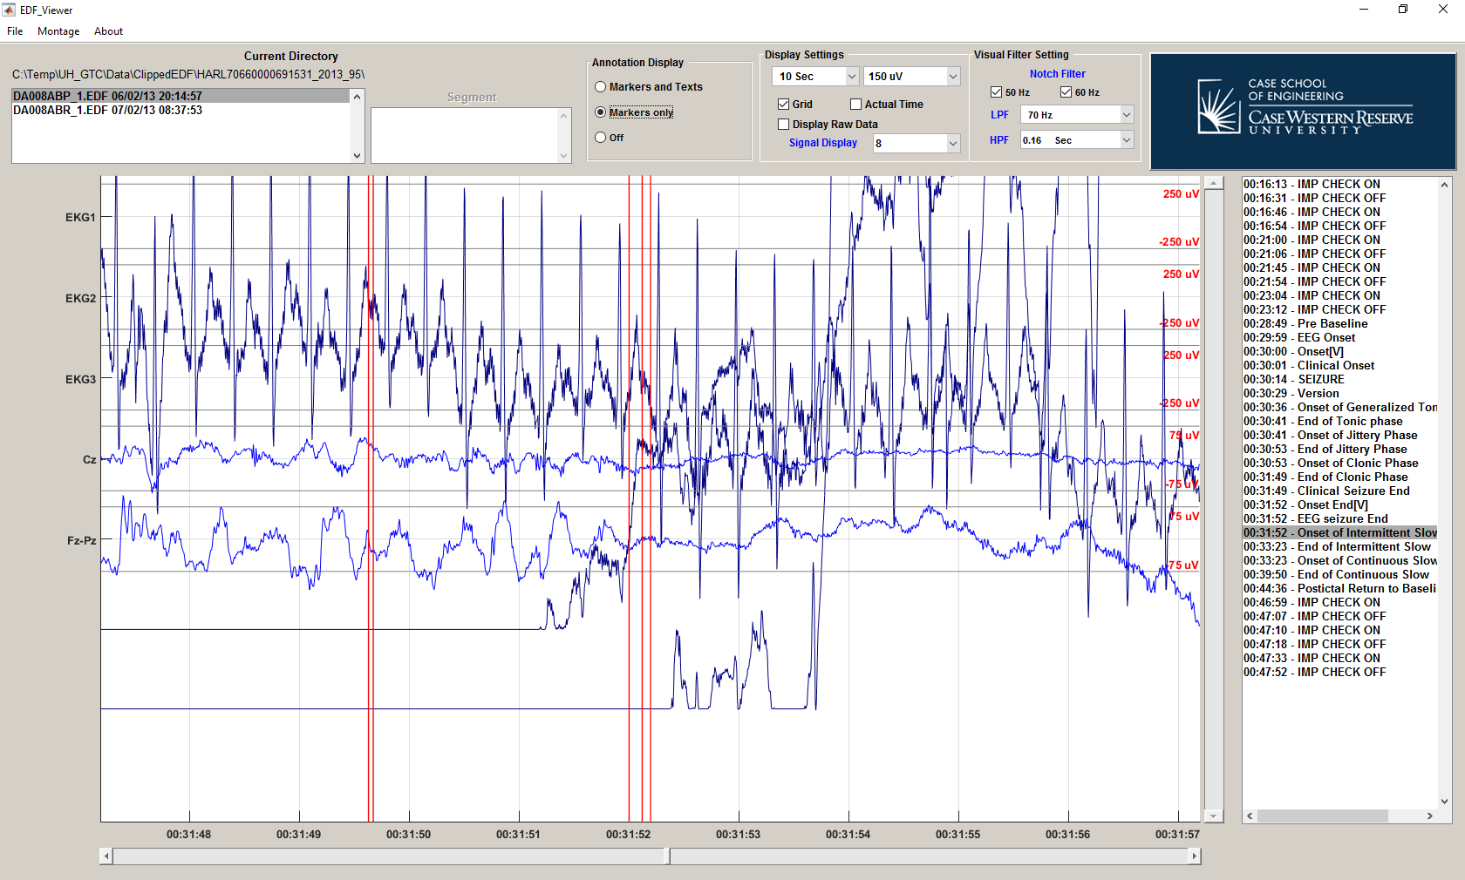

The last option, “Off”, will turn off all markers for clinical annotation.

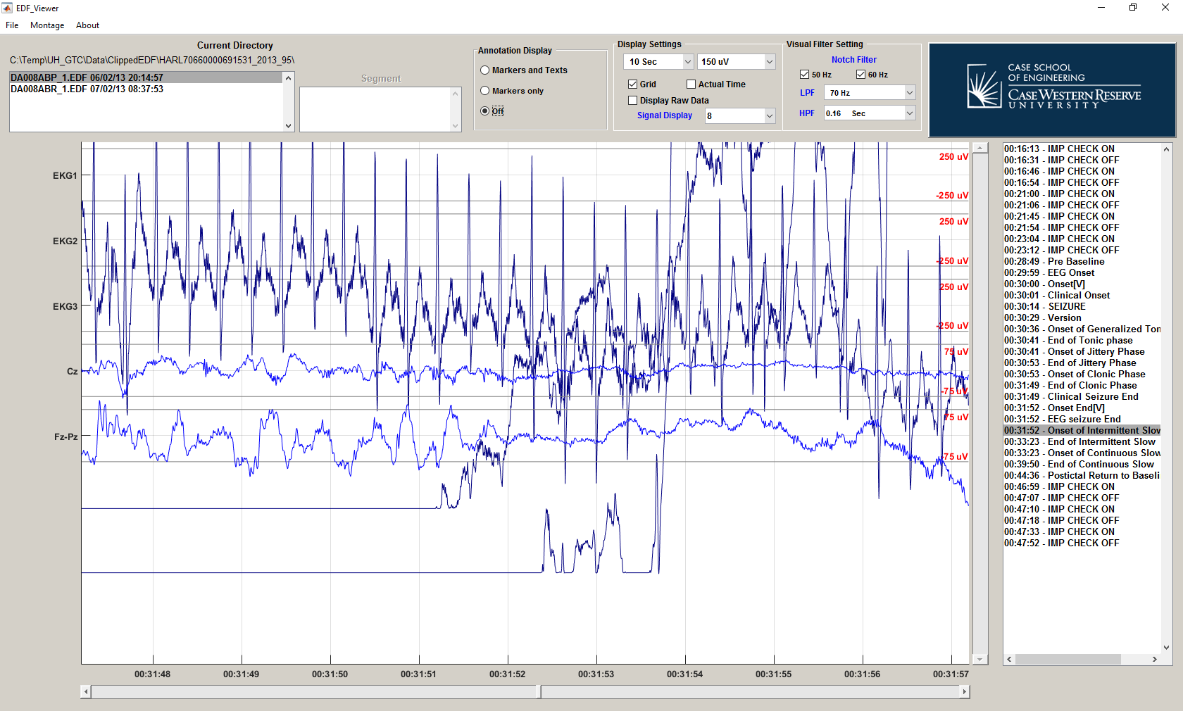

User can adjust the duration of the signals on the screen using top-left popup menu in the “Display Setting”.

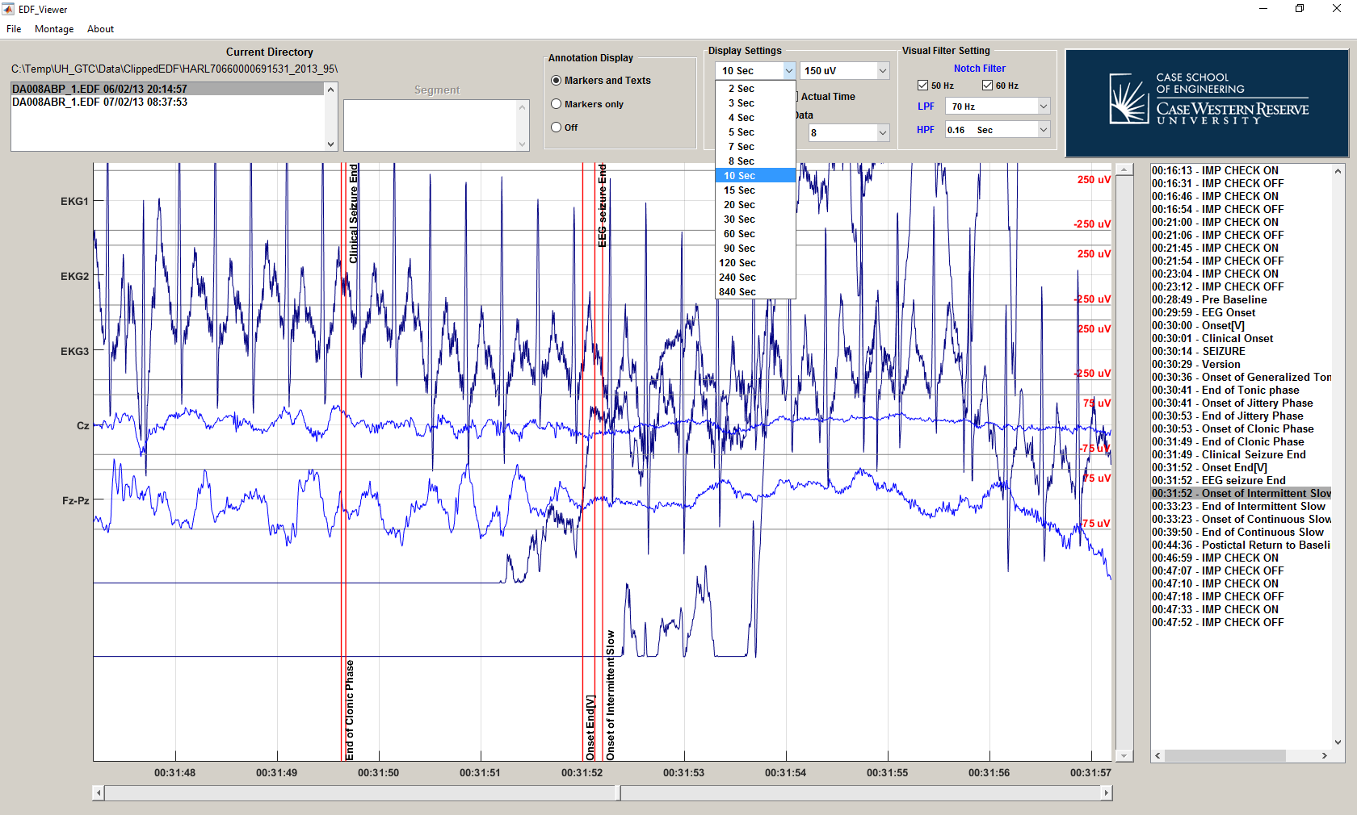

In the “Display Setting”, there are three check boxes, “Grid”, “Actual Time” and “Display Raw Data”. The “Grid” check box will turn on/off the horizontal and vertical grid in the display. Not that the horizontal line associated with the scaling of signal will remain even of the “Grid” check box is turned off.

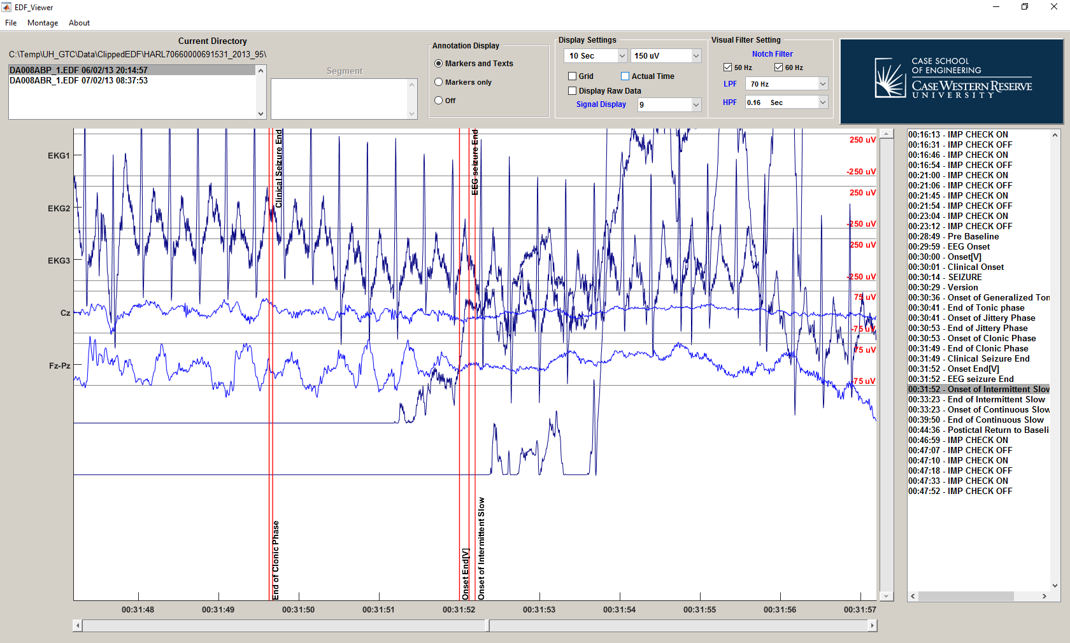

When “Actual Time” check box is turned off, the time displayed on the bottom of the screen and the time in the annotation list is reference with the beginning of the data file.

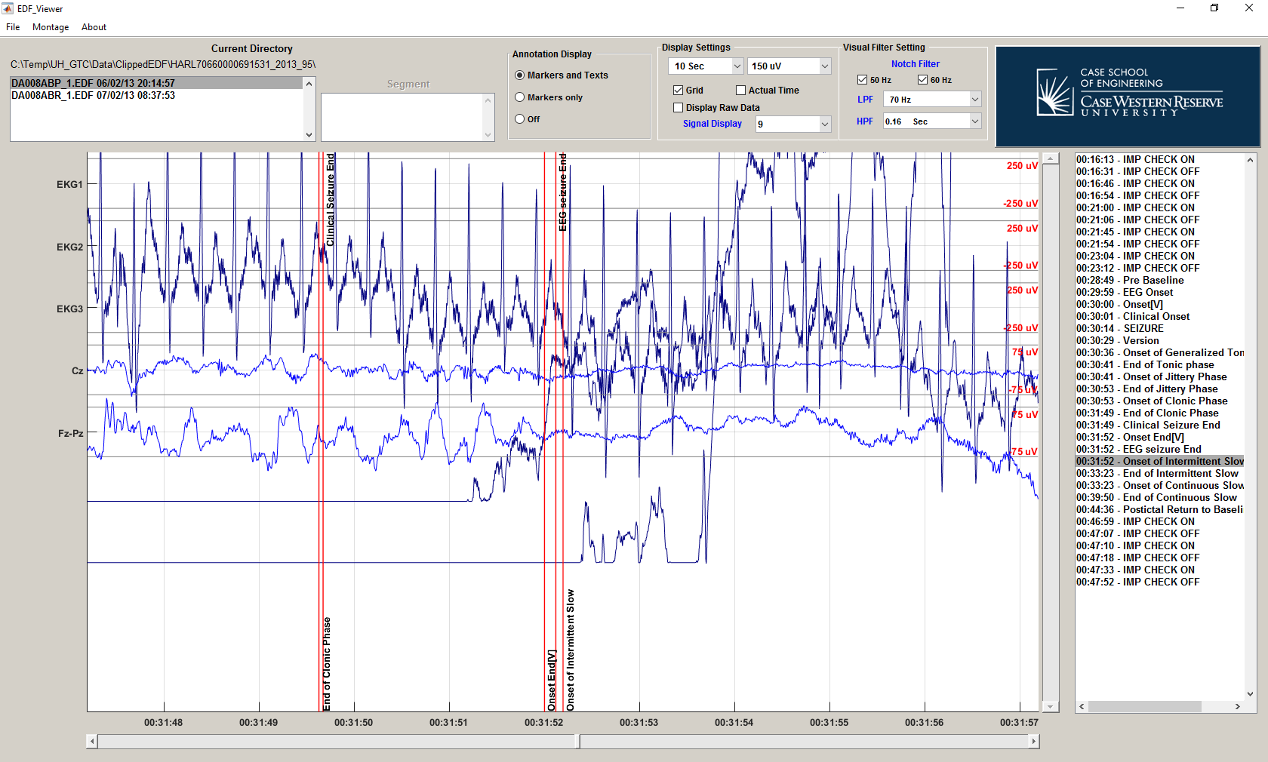

When “Actual Time” check box is turned on, the time displayed on the bottom of the screen and the time in the annotation list is the actual time of the recording.

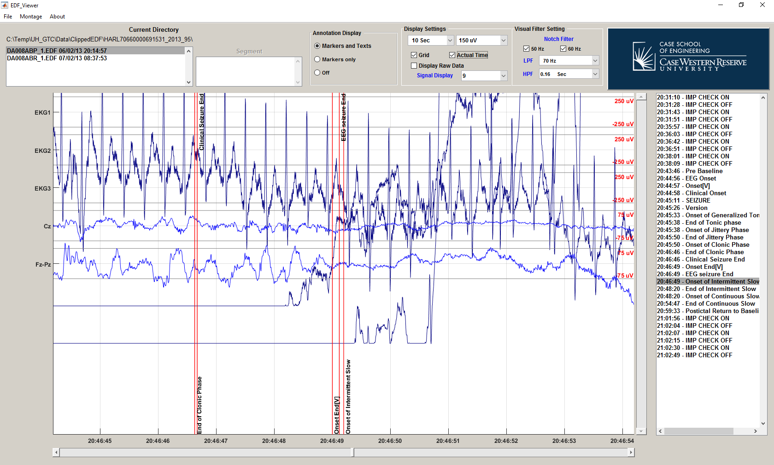

When “Display Raw Data” check box is turned off, the signals in the display screen will be filtered before display. Some signals might not have filter in there display setting. The filtered signal will be the dark blue color while the filtered signal will have the blue color.

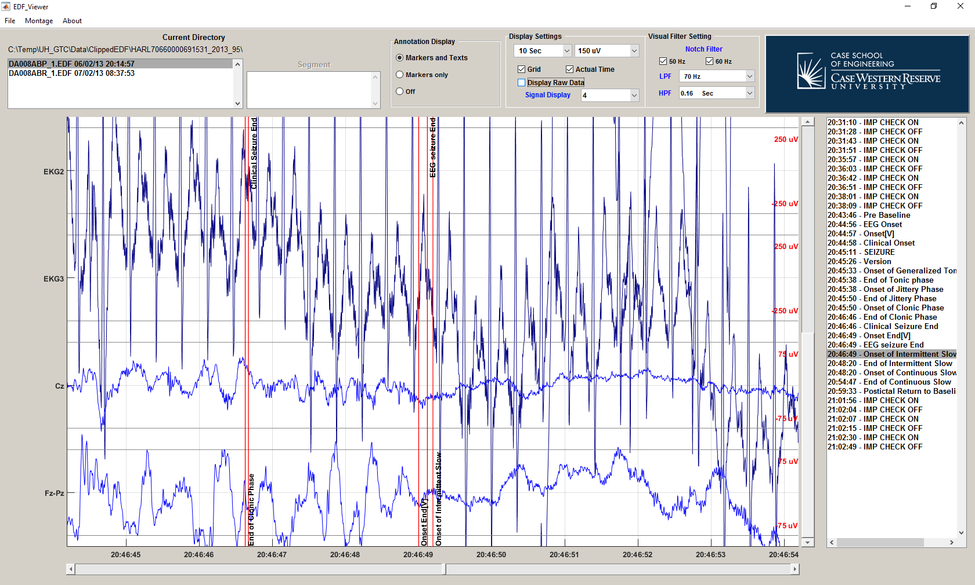

**Filtered Signals**

**Unfiltered Signals**

When “Display Raw Data” check box is turned off, the signals in the display screen will be displayed without any filtering.

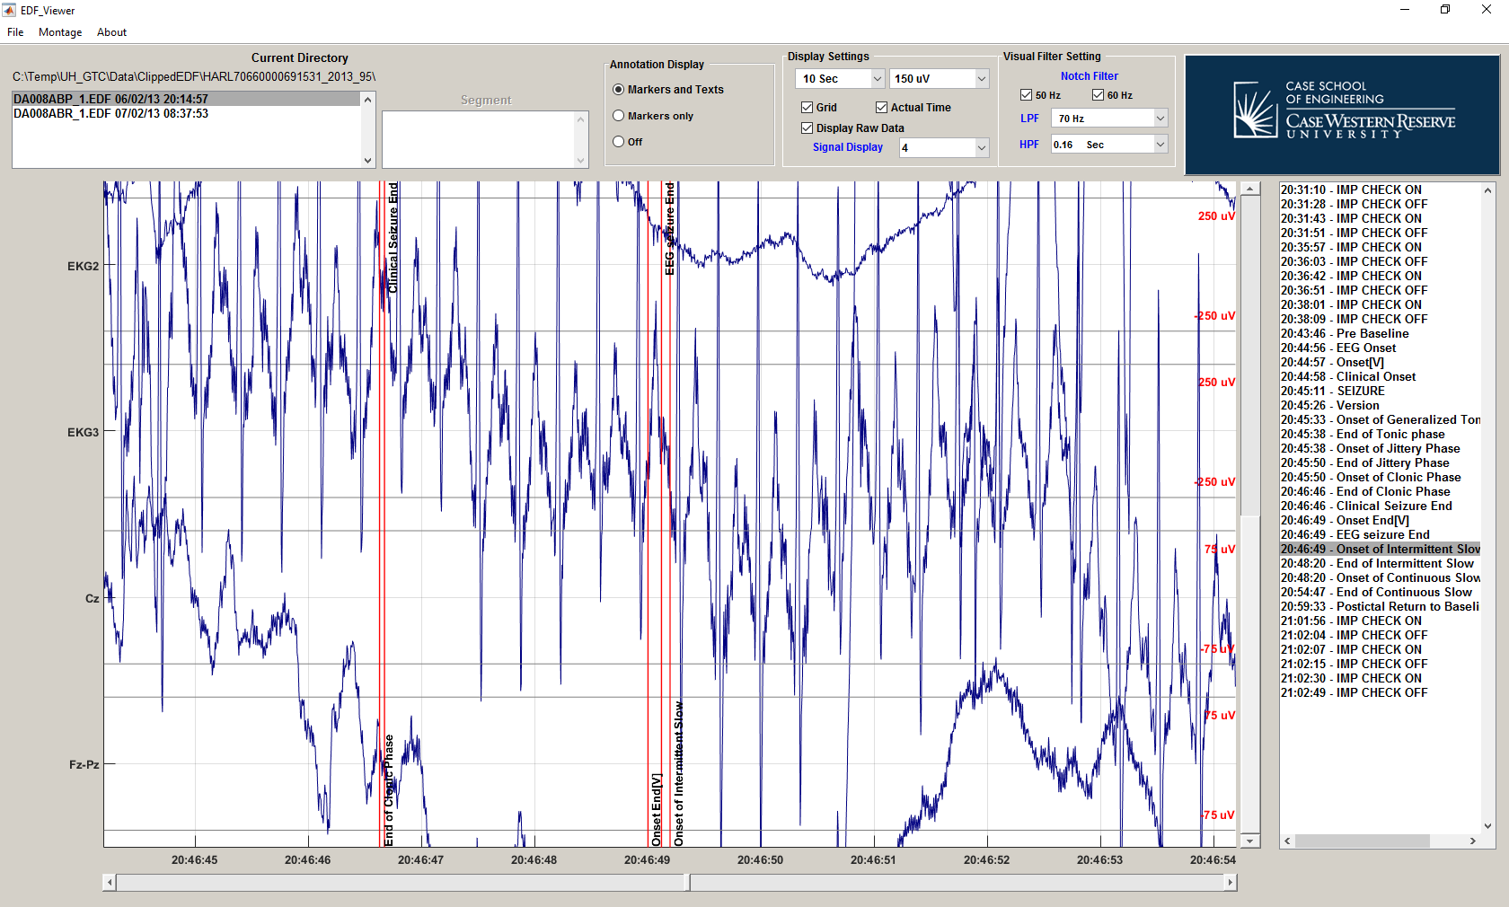

User can adjust how many signals to be displayed by using the “Signal Display” popup menu in a “Display Setting”.

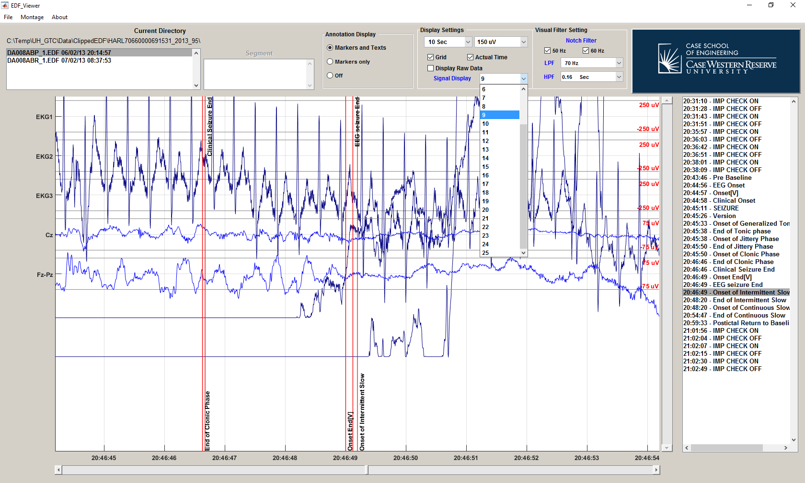

If the number of signal in the display setting is less than the selected signal in the “Montage” menu, user can scroll down using the slider on the right of display screen to view other signals that were not in the display screen.

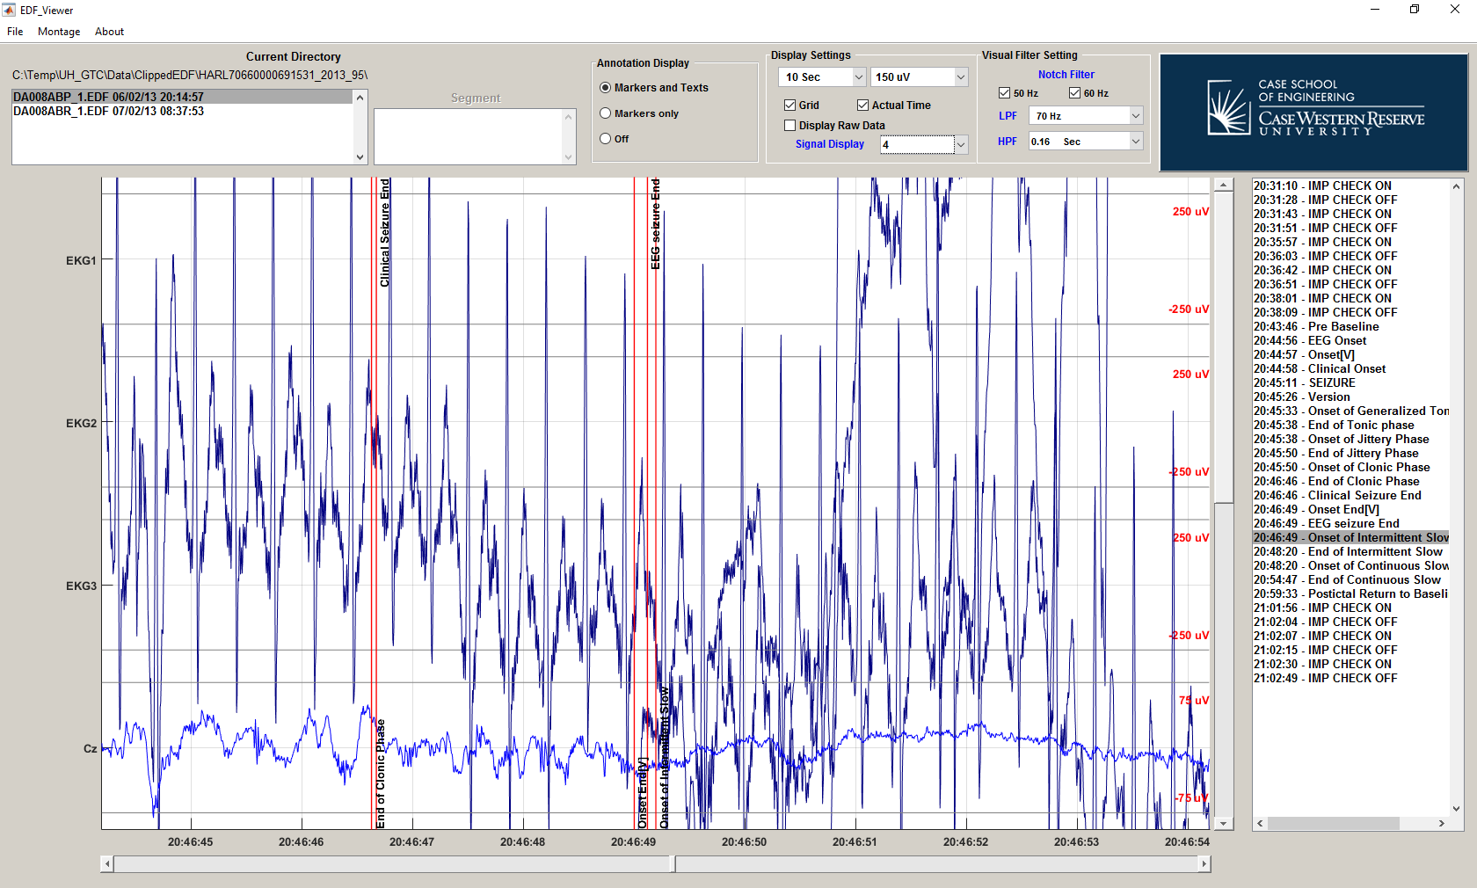

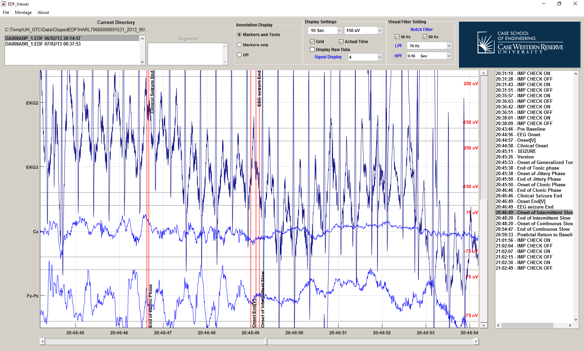

If the number of signal in the display setting exceeds the number of selected signals in the “Montage” menu, some portion of the display screen will be empty.

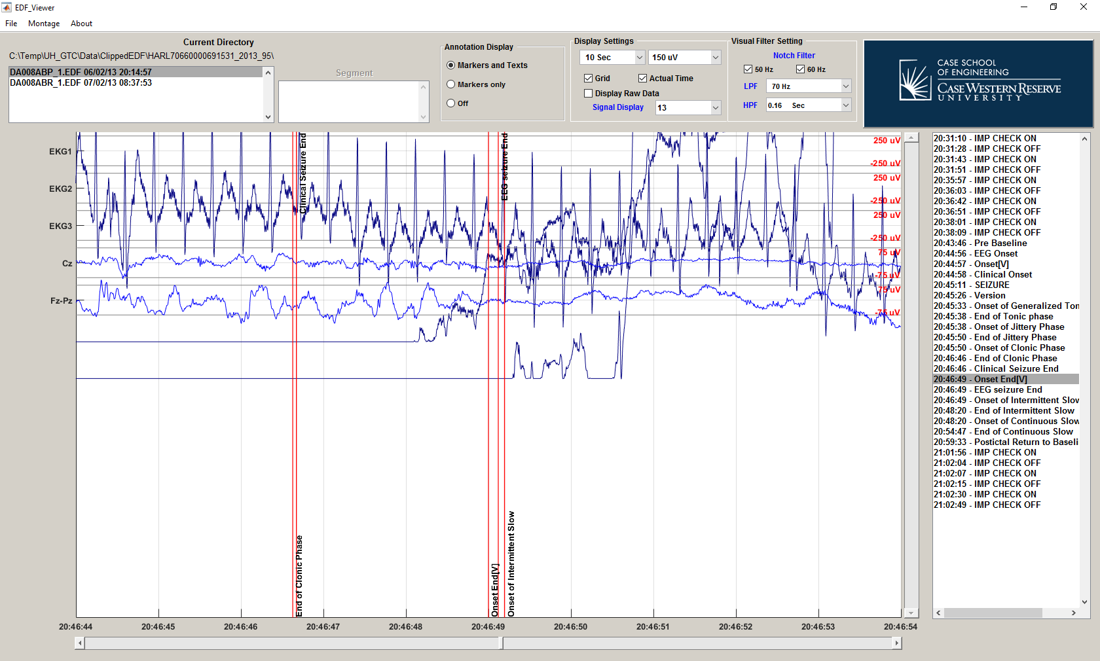

**Empty signals**

# EEGs and non-EEGs Display Setting

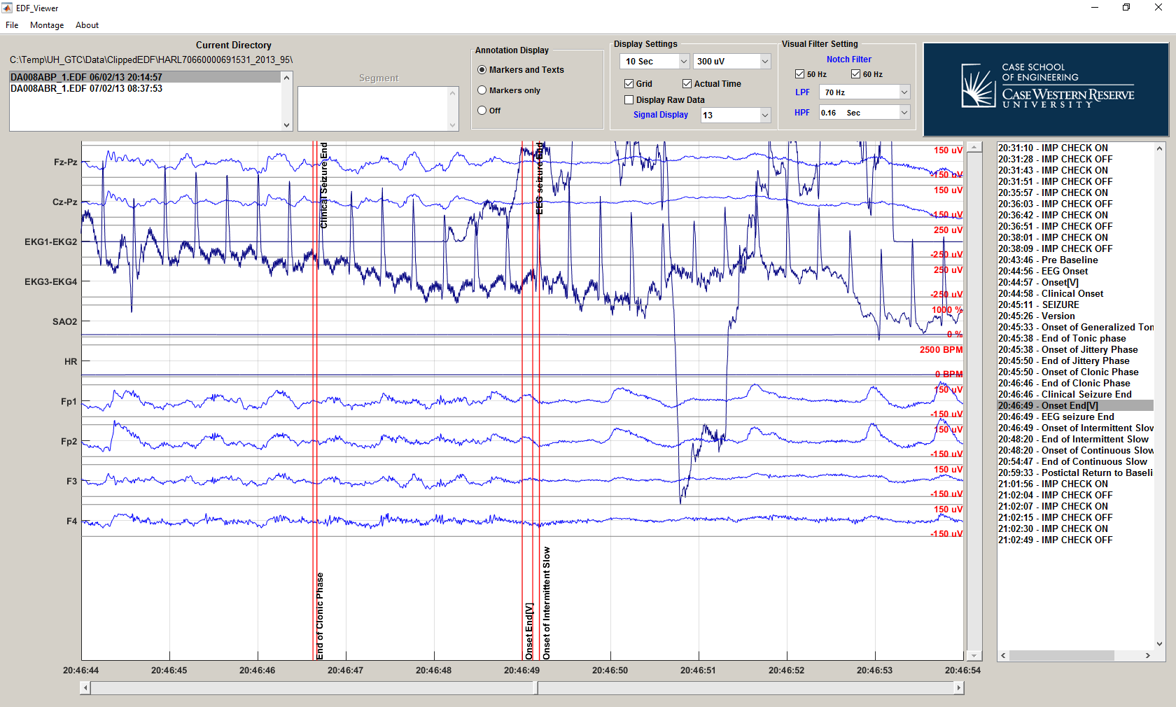

Since EDF Viewer is design to view the data for SUDEP research, display for all EEG signals are linked together for convenient of main usage. EEGs include both scalp and intracranial EEGs. The program will automatically assume that the unknown channel is EEGs which could be undesirable in some case. However, user can manual link and unlink signal from EEG display. This can be done in signal display setting.

To open signal display setting click on the channel names on the left side of display screen.

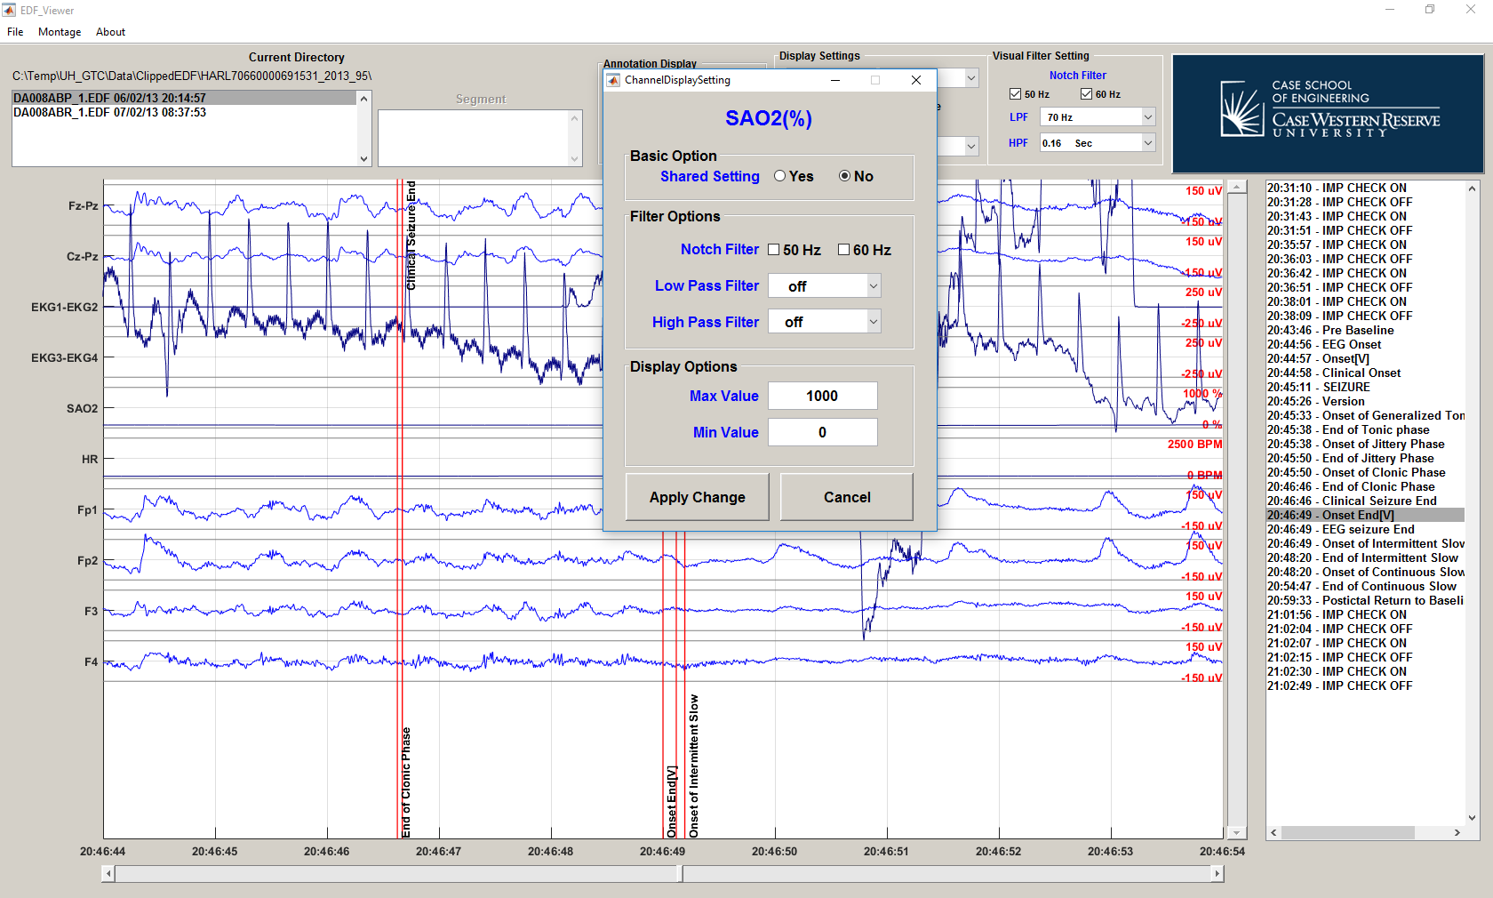

In the signal display setting, there will be several options that user can adjust.

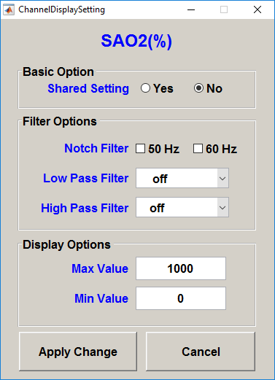 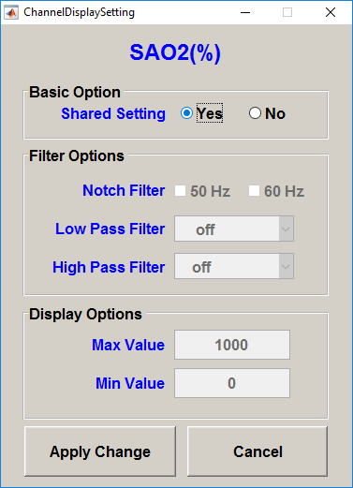

The first option is to link the signal with EEGs in the “Basic Option”. If user select “Yes” in “Shared Setting”, the signal display will use the main setting in the main window and disable other setting. This option is for EEGs signal visualization with usually involves more than 18 EEG channels.

For Non-EEG signal, select “No” in “Shared Setting”. User will be able to select custom filter setting which include high pass filter, low pass filter and notch filter for individual channel in “Filter Options”.



For Non-EEG signal, the range (maximum and minimum of display scale) can be adjusted in “Display Options”.

In contrast, for all EEGs, filter setting can be adjusted on “Visual Filter Setting” in the main screen.



All EEG signals always center at 0 uV and the range (sensitivity) in the display can be adjust in the popup menu in “Display Setting” of the main window.

